GFG-160 | DAY 01

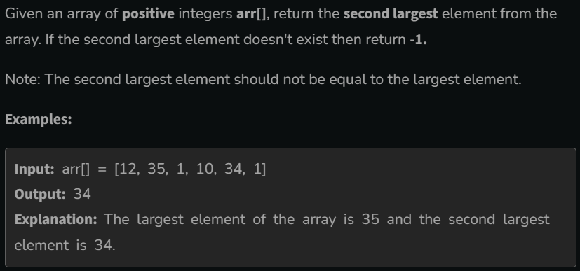

Answer

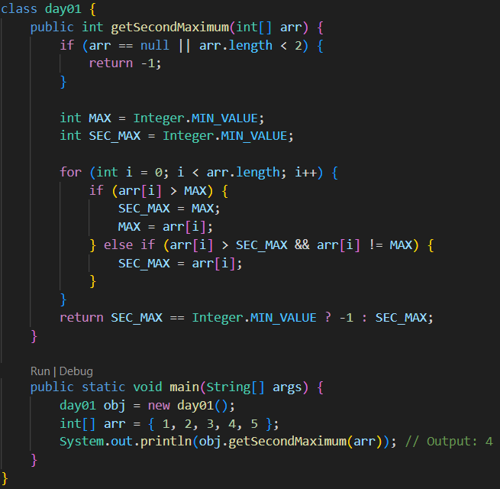

Here we have to find the second maximum value of the given array. If the array has not second maximum value, which means the array has only one value or all the values are same values. If so, we have to return -1.

Let’s break code line by line.

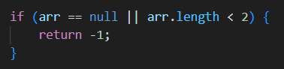

Here, I check whether the array is null or its length is less than 2. If so I return -1.

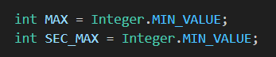

Here I declared two integer variables called MAX and SEC_MAX. I use the MAX variable to store the largest number of the array. Initially, I stored the smallest value using MIN_VALUE. I used the SEC_MAX variable to store the second maximum value of the array. Also here, I store the smallest value for now. Here smallest value is not of the array’s smallest. It is the int range’s smallest value (-2147483648). So, for now, MAX and SEC_MAX both are -2147483648.

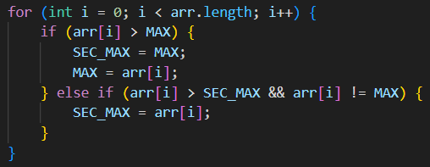

Here, there is a for loop. Here check whether the i (1) is greater than MAX(-2147483648). If so, MAX is assigned to SEC_MAX. Which means SEC_MAX is also -2147483648. In the below line, MAX is changed to the array’s current value(1). This process happens until the loop ends. Below is the process.

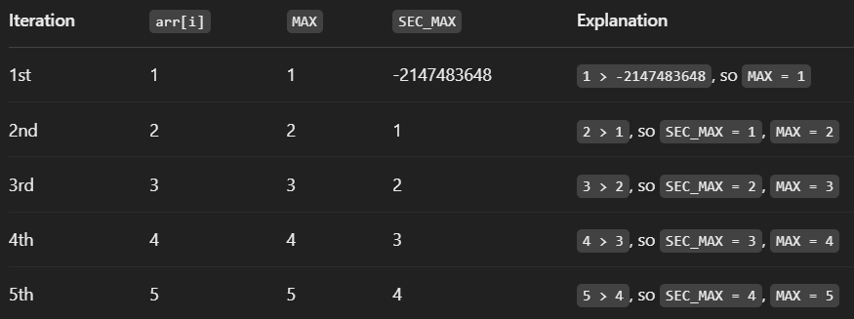



Here, we can check whether the SEC_MAX value is still -2147483648. If it is not, we can return the SEC_MAX value. According to the above explanation, the output is 4.